Supplementary Materials
Appendix A:
- Most Global Cited Documents
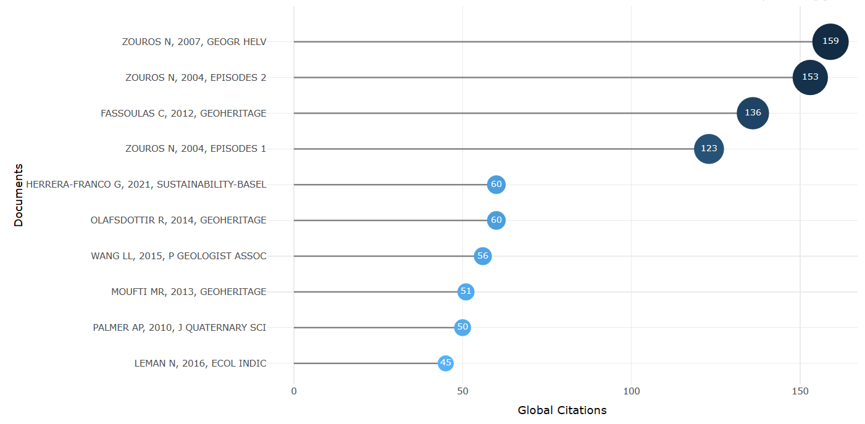
- Most Local Cited Documents
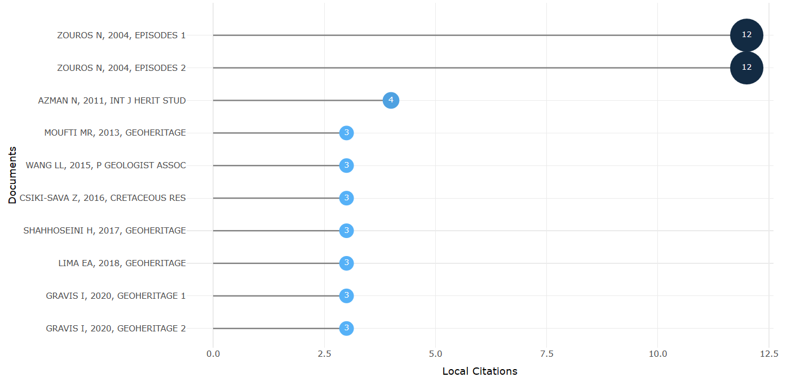

- Most Relevant Affiliations
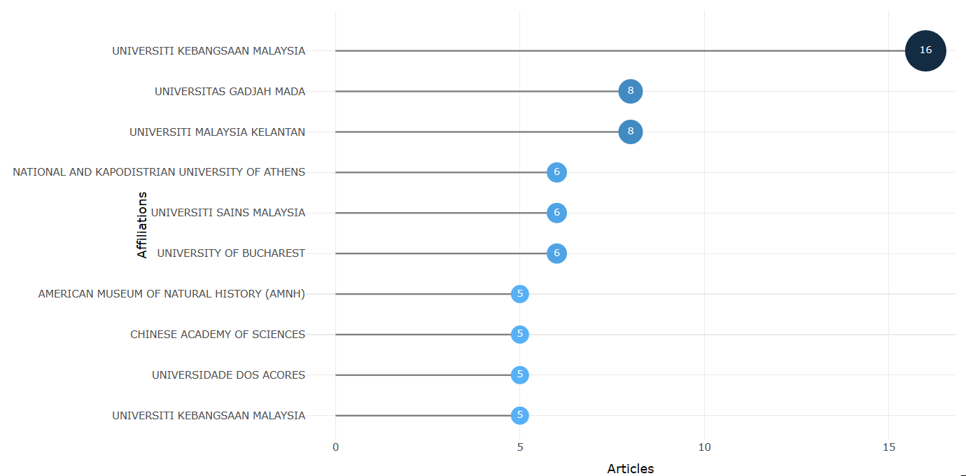
Appendix B:
- Co-citation Network: Sources

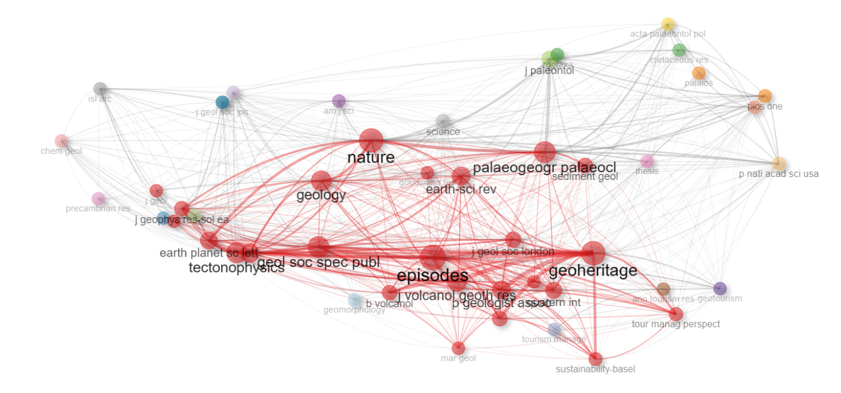

- Co-citation Network: Papers
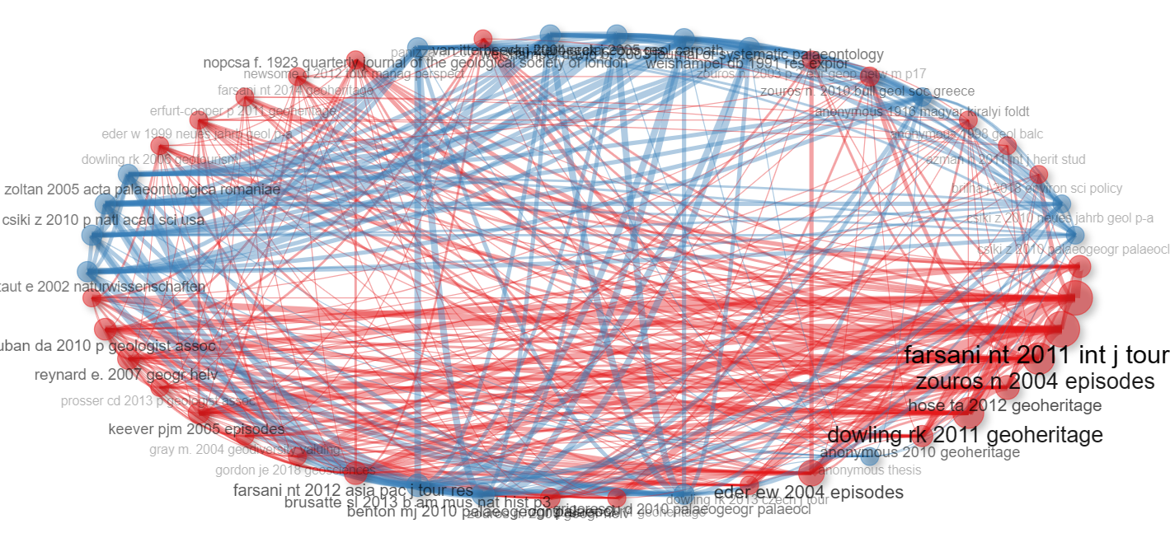

Appendix C:
- Three Field Plot: Keywords (DE), Sources (SO) and Countries (AU_CO)
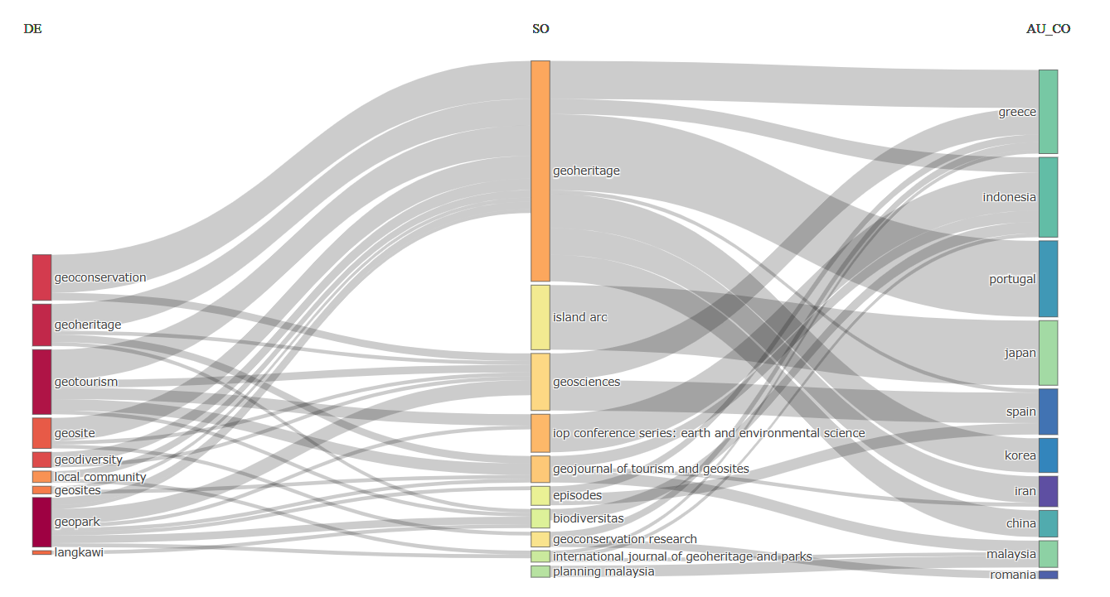
- Three Field Plot: Keywords (DE), Abstracts (AB_TM) and Countries (AU_CO)

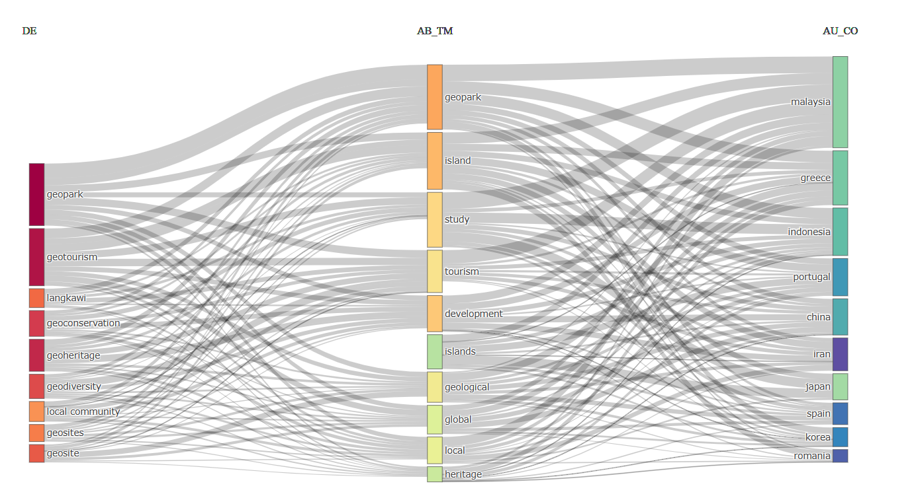
- Three Field Plot: Keywords (DE), Authors (AU) and Countries (AU_CO)

